**Analysis Swiggy: Bangalore delivery outlet data**

**Architecture**

Revision Number: 1.0

Version: 1.0

Author: Mohammad Wasiq

E-mail: [gl0427@myamu.ac.in](mailto:gl0427@myamu.ac.in)

Last Date of Revision: 16/03/2023

Analysis Swiggy: Bangalore Delivery Outlet Data Architecture

**Table of Contents**

1 Introduction 2

2 Scope 2

3 Architecture 2

4 Deployment …………………………………………………………………………………………………………… 4

# 1 Introduction

## The online food ordering market includes foods prepared by restaurants, prepared by independent people, and groceries being ordered online and then picked up or delivered. The first online food ordering service, World Wide Waiter (now known as Waiter.com), was founded in 1995. Online food ordering is the process of ordering food from a website or other application. The product can be either ready-to-eat food or food that has not been specially prepared for direction consumption.

## 2 Scope

## The aim of this project is to find out who is the best restaurants, highest rating, cost, cuisine cost, expensive restaurants with respective areas. There are four dashboards showing Shop name with rating, Cost of cuisines, Places in different professions. Dashboards show in which area the expensive restaurants are there, what is rating, what all items available, etc. so that each and every one can analyse which restaurant is the best according to cost and ratings.

# Architecture

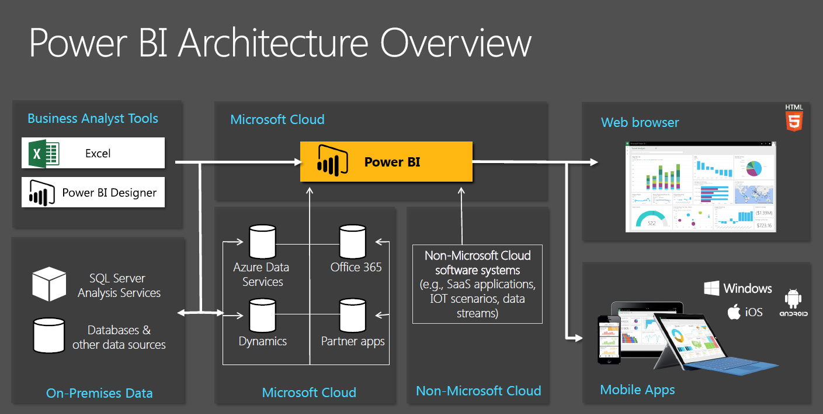

* **Power Query:**

Power Query is a data transformation and preparation engine. Power Query comes with a graphical interface for getting data from sources and a Power Query Editor for applying transformation.

* **Power Pivot:**

Power Pivot is used to model the data and perform more complex calculations than Excel can handle. Power Pivot is great when working with huge data sets.

* **Power View:**

Power View is a data visualization technology that create interactive charts, graphs, maps, and other visuals that bring data to life. Power View is available in Excel, SharePoint, SQL Server, and Power BI.

* **Power Map:**

Microsoft Power Map for Excel is a three-dimensional (3-D) data visualization tool that look at information in new ways. A power map discover insights might not see in traditional two-dimensional (2-D) tables and charts.

* **Power BI Desktop:**

Power BI Desktop is built for the analyst. It combines state-of-the-art interactive visualizations, with industry-leading data query and modelling built-in. Create and publish reports to Power BI. Power BI Desktop helps empower others with timely critical insights, anytime, anywhere.

* **Power BI Services:**

Power BI service is the Software as a Service (SaaS) part of Power BI. It is known as Power BI Online. To access Power BI Service, you need to log in to Power BI service.

* **Power Q&A:**

The Power Q&A feature in Power BI explores data in your own words. The first part of this article shows how you use Q&A in dashboards in the Power BI service. The second part shows what you can do with Q&A when creating reports in either the Power BI service or Power BI Desktop.

1. 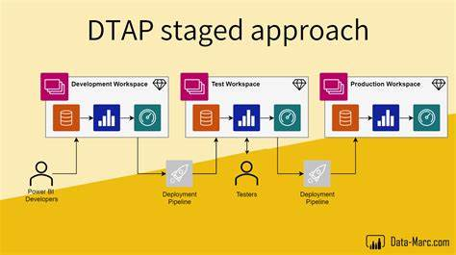**Deployment**

There are multiple ways to deploy the dashboard in Power BI. The simplest way is to publish directly on Power BI Services server from online mode. One can easily publish the work from the desktop and then it will open in browser, then user has to sign in the work will be published.

This work can see all the viewers around the world. You can share it via a sharable link.

Thus, user can deploy a dashboard using Power BI Services.